**THE UNIVERSITY OF ECONOMICS AND FINANCE**

**FACULTY OF INFORMATION TECHNOLOGY**

|  |
| --- |
|  |

**COURSE MANAGEMENT SYSTEM**

**Major: Java Technology**

**Class: B03E**

**Supervisor: Nguyen Van Tan**

***Group Members:***

1. *Chu Thi Mai Huong - 195050876*
2. *Nguyen Van Lam - 195050989*
3. *Tran Minh Tien - 195050615*

**Ho Chi Minh City - 2022**

**THE UNIVERSITY OF ECONOMICS AND FINANCE**

**FACULTY OF INFORMATION TECHNOLOGY**



**COURSE MANAGEMENT SYSTEM**

**Major: Java Technology**

**Class: B03E**

**Supervisor: Nguyen Van Tan**

***Group Members:***

1. *Chu Thi Mai Huong - 195050876*
2. *Nguyen Van Lam - 195050989*
3. *Tran Minh Tien - 195050615*

**Ho Chi Minh City - 2022**

# Table of contents

Table of contents 3

figure catalog 6

table catalog 7

ABSTRACT 8

Chapter 1. Introduction 9

1. Introduction 9

2. Motivation 9

3. Goal of The Project 10

4. Expected of Consequence 10

5. Project Plan 10

Chapter 2. SYSTEM ANANLYSIS AND REQUIREMENT SPECIFICATION 12

1. Application Process Modeling 12

2. Requirement Analysis 12

2.1. Hardware And Software Requirements 13

3. Design And Model Requirements 13

Chapter 3. SYSTEM DESIGN 14

1. Use Case Modeling 14

2. System Context Diagram 16

3. Class Diagram 18

4. Sequence Diagram 23

Chapter 4. CONSTRUCTING THE COURSE MANAGEMENT SYSTEM 25

Chapter 5. DEMO PROJECT 28

1. Login 28

2. Admin Interface 29

Chapter 6. Conclusion And Future Development 37

1. Conclusion 37

2. Outcome 37

3. Limitation 37

4. Future Development 37

# figure catalog

Figure 3. 1. Administrator Use Case Diagram 13

Figure 3. 2. Student Use Case Diagram 14

Figure 3. 3. Instructor Use Case Diagram 14

Figure 3. 4. Zero Level Context Diagram Of Course Management System 15

Figure 3. 5. 1st Level Context Diagram of Course Management System 16

Figure 3. 6. 2nd Level Context Diagram of Course Management System 16

Figure 3. 7. Class Diagram 17

Figure 3. 8. Administrator Module Sequence Diagram 22

Figure 3. 9. Login Student Sequence Diagram 22

Figure 3. 10. Login Instructor Sequence Diagram 23

# table catalog

Table 1. 2. Plan 8

Table 3. 1. Class Administrator 17

Table 3. 2. Class Account 18

Table 3. 3. Class Subject 18

Table 3. 4. Class Student 19

Table 3. 5. Class Instructor 20

Table 3. 6. Class AssignSubject 20

Table 3. 7. Class Marks 20

# ABSTRACT

This project “Course Management System” is a system based on desktop application which is useful for students and instructors. By using this application will make the students less wasted time, and they will be able to easily get all the studies information from their instructors. As a result, they will be able to continue their studies better.

Moreover, the primary goal of the project is to facilitate seamless interaction between students and instructors in schools, colleges, and universities concerning the submission of projects, assignments, thesis, and receiving feedback from instructors.

**Student Module** - By using this application, students will be able to check if their Instructors has given them a mark for their homework. Students also can ask any studies related questions to their instructors, etc.

**Instructor Module** - By using this application, instructors can see how many students have the course. If there are more than a certain number of students, then the Instructors can disable this course for another student. By using our “chat function”, an instructor can communicate with his/her students, send feedback and offer guidance to them, etc.

**Administrator Module** - By using this application, the administrator can manage accounts for students and instructors, creating the curriculum, coding the subjects, etc. Basically, this module lays the groundwork for the other two modules above.

Along with the administrator, both the students and instructors will benefit from these functionalities and it works to run more smoothly because face-to-face meetings are not held very frequently.

# Introduction

## Introduction

This application will be most convenient for students' study purpose, administrator and instructors management purposes, and they will be benefited most. Because this application has beneficial and helpful features that will be used by the student, instructors, and administrator.

In this application, there are three panels. Administrator, instructors and students panel. By this application, students can see their classmates, get their course and subject  information. They can see and ask their instructors from the “chat function” which has been provided by their instructor. By using this application, instructors can post class materials such as marks for the students. Instructors can give any declaration of the student's study purpose. By using this application, administrator can add any instructors, students, and curriculums. An administrator can create a new user, update, edit, delete any other content. By using this application, administrator can check total students and instructors, how many courses are under the instructor can monitor. By using this application, administrator can access all of the portal.

As a result, our goal was to simplify the students' study easier and move them forward along with the instructors .

## Motivation

The total concept of that task began through a little illustration which we got from our homework. We wanted to, how students can easily study while maintaining time to move forward. So, we think that there is a demand for a system that will be helpful for the students and instructors.

We included some features in this application, in the point of view that students will get facilities from the application that will be beneficial and preferable. From our side, this application will be helpful, easy to use and user friendly.

## Goal of The Project

In order to the intention of achieving this aim, we will:  
▪ Instructors can post class materials such as course handouts.  
▪ The Instructors can see how many students has to the course. If there are more  
than a certain number of students, then the Instructors can disable this course for  
another student.

▪ Instructors can add new courses.

▪ Students can view or save course-related information.

▪ Students can ask instructors for guidance. The system will notify students whenever their instructor sends feedback.

▪ Students can enroll in a course.

▪ Every user has an Id.

## Expected of Consequence

This application has effective features which will provide the users good service. So that we can fulfill following the expected consequences:

▪ Increases interconnection between instructors and students.

▪ Saves time for the students and instructors.

▪ Increases the quality of student’s studies and learning.

▪ Develops both student’s and instructor’s performance.

▪ Reducing the barriers to student studies.

▪ Increases student’s relationship with study.

## Project Plan

|  |  |  |
| --- | --- | --- |
| **ID** | **Full name** | **Task** |
| 195050876 | Chu Thi Mai Huong | Abstract  **Chapter 1.** Introduction  **Chapter 3.** Design |
| 195050 | Nguyen Van Lam | **Chapter 2.** Analysis  **Chapter 6.** Conclusion and Future Conclusion |
| 195050 | Tran Minh Tien | **Chapter 4.** Implementation  **Chapter 5.** Application Demo |

Table 1. . Plan

# SYSTEM ANANLYSIS AND REQUIREMENT SPECIFICATION

## Application Process Modeling

This application process modeling presents the entire systems whole working procedure. The method can represent the all thoughts of a process. At first, we have to make sure the requirement and application process before we start the development process. So, we building many diagram for fulfilled our requirement. The diagram like E-R diagram, use case diagram, block diagram and context diagram.

## Requirement Analysis

The system will have some requirements in the following:

* The system has three panels (modules):
* Administrator module:
  + - Allow administrator to creating accounts for students and instructors
    - Creating the curriculum, coding the subjects, managing the employees, payroll, and so on.
* Students module:
  + - Allow they to log in to their accounts to view their coursework, submit their projects, get feedback from instructors, etc.
* Instructor module:
  + - Allow instructor to log in to their accounts and manager related student information.
* User friendly, easy to use
* Information security
* Allow multiple users to login

### Hardware And Software Requirements

Hardware Requirements:

* Storage: Minimum 1.5GB Storage.
* Ram: Minimum 4GB.
* Laptop or PC

Software Requirements:

* Database: MySQL
* Operating System: Windows, Linux
* Application: Eclipse IDE (with Windowbuilder installed to use Java Swing),…
* Language: Java
* For Design: JFrame

## Design And Model Requirements

This should be a course management system like an online management software application designed for educational institutions. The main requirement of the project is to create a seamless interaction between students and instructors in high schools, colleges and universities in regards to assignments, dissertations and getting feedback from instructor. This project has three interconnected modules: Administrator, students and instructor.

# SYSTEM DESIGN

## **Use Case Modeling**

A use case model describes different types of user interacts and their activities into a system. It is also a list of actions done by the user. The number of elements like as: an actor, an event, a use case. The major component is the actor.

We have three actors in our project, they are:

* **Administrator:**

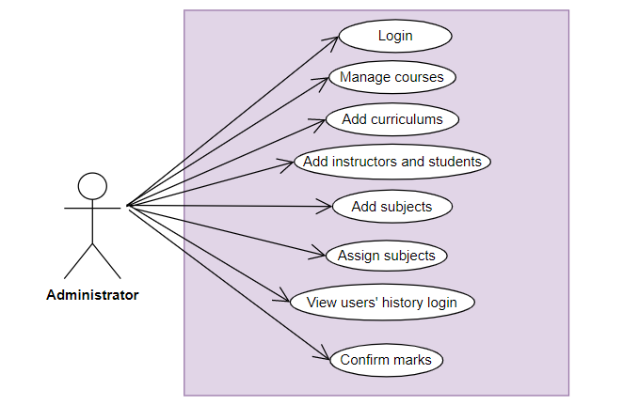

Figure 3. . Administrator Use Case Diagram

* **Student:**

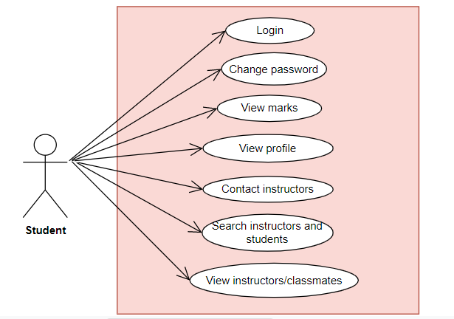

Figure 3. . Student Use Case Diagram

* **Instructor:**

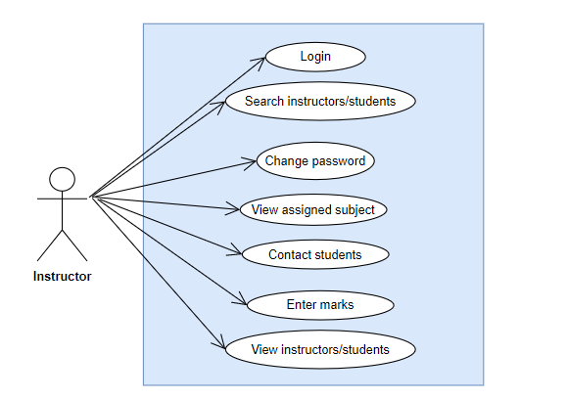

Figure 3. . Instructor Use Case Diagram

## System Context Diagram

A Context Diagram is the highest level of data flow diagram. It represents the flows of information between the system and all external entities that may have interact with a system. The entire software system is shown as a single process.

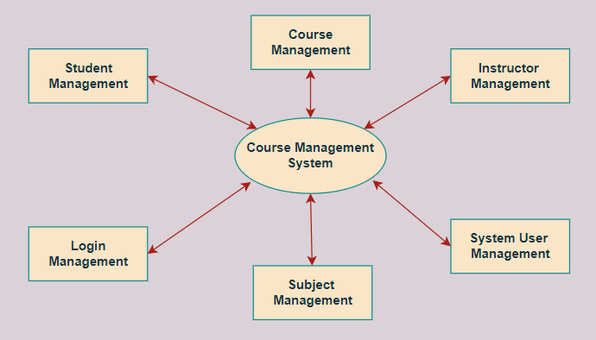

Figure 3. . Zero Level Context Diagram Of Course Management System

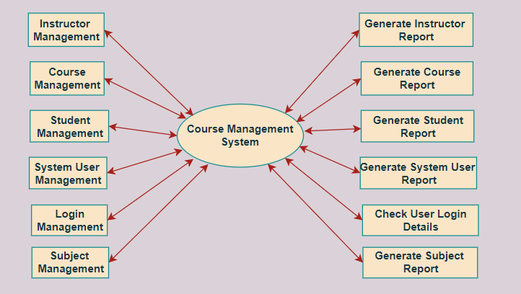

Figure 3. . 1st Level Context Diagram of Course Management System

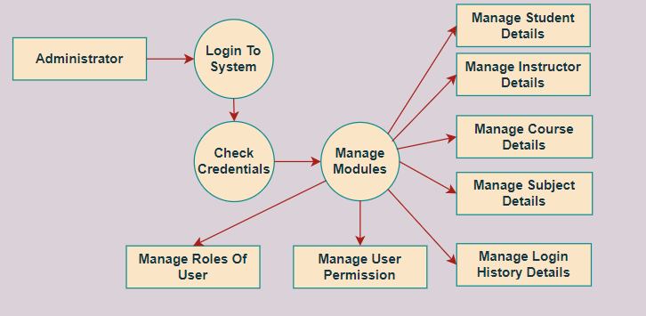

Figure 3. . 2nd Level Context Diagram of Course Management System

## Class Diagram

Figure 3. . Class Diagram

***Class Administrator***

|  |  |  |  |  |
| --- | --- | --- | --- | --- |
| **Attributes** | **Access Modifiers** | **Data Type** | **Description** | **Class Description** |
| Instructor Name | public | varchar | Display the name of Instructor  Null | - This class is related to the management of Account.  - **Instructor ID** is the primary key. |
| Instructor ID | public | int | Each Instructor has a unique id and is linked to exactly one Instructor. |
| Email ID | public | varchar | * Only account Email ID * - Null. |
| Qualification | public | varchar | * Null |
| Contact Number | Public | varchar | * Instructor contact information * Null |
| Gender | Public | varchar | * Null |
| State | Public | varchar | * Null |
| Date of Birth | Public | varchar | * Null |
| City | Public | varchar | * Null |
| Experience | Public | varchar | * Null |
| Image | Public | varchar | * Null |

Table 3. . Class Administrator

***Class Account***

|  |  |  |  |  |
| --- | --- | --- | --- | --- |
| **Attributes** | **Access Modifiers** | **Data Type** | **Description** | **Class Description** |
| ID | public | int | Each account has a unique id and is linked to exactly one account. | - This class is related to the management of Instructor and Student  - **ID** is the primary key. |
| Password | public | varchar | * One of the required attributes, used for login * Not Null |
| Position | public | varchar | * Null. |

Table 3. . Class Account

***Class Subject***

|  |  |  |  |  |
| --- | --- | --- | --- | --- |
| **Attributes** | **Access Modifiers** | **Data Type** | **Description** | **Class Description** |
| ID | public | int | Each subject has a unique id and is linked to exactly one subject. | - This class is related to the management of administrator.  - **ID** is the primary key. |
| Name | public | varchar | * Null |
| Calendar | public | varchar | * Null |

Table 3. . Class Subject

***Class Student***

|  |  |  |  |  |
| --- | --- | --- | --- | --- |
| **Attributes** | **Access Modifiers** | **Data Type** | **Description** | **Class Description** |
| First Name | public | varchar | Each product has a unique id and is linked to exactly one product. | - This class is related to the management of account  - **Roll Number** is the primary key. |
| Email ID | public | varchar | * Must contain the minimal information needed to identify the item. |
| Roll Number | public | int | * One of the required attributes, * Not null. |
| Image | Public | varchar | * Null |
| Password | Public | varchar | * One of the required attributes, used for login * Not null |
| Last Name | Public | varchar | * Null |
| City | Public | varchar | * Null |
| Date of Birth | Public | Varchar | * Null |
| State | Public | Varchar | * Null |
| Parents | Public | Varchar | * Null |
| Contact Number | Public | Varchar | * Null |

Table 3. . Class Student

***Class Instructor***

|  |  |  |  |  |
| --- | --- | --- | --- | --- |
| **Attributes** | **Access Modifiers** | **Data Type** | **Description** | **Class Description** |
| Instructor Name | public | varchar | * Show Instructor's name * Null | - this class has a relationship with the class administrator  - **Instructor ID** is the primary key. |
| Instructor ID | public | int | * Distinguish between instructors * Instructor ID is unique |
| Email ID | public | varchar | * Null. |
| Qualification | Public | Varchar | * Null |
| Contact Number | Public | Varchar | * Null |
| Gender | Public | Varchar | * Null |
| State | Public | Varchar | * Null |
| Date of Birth | Public | Varchar | * Null |
| City | Public | Varchar | * Null |
| Experience | Public | Varchar | * Null |
| Image | Public | Varchar | * Null |

Table 3. . Class Instructor

***Class AssignSubject***

|  |  |  |  |  |
| --- | --- | --- | --- | --- |
| **Attributes** | **Access Modifiers** | **Data Type** | **Description** | **Class Description** |
| ID_Subject | Public | Int | Each assign has a unique id and is linked to exactly one assign subject. | - This class is used to divide teaching activities for instructor  - **ID_Subject** is the primary key. |
| Subject Name | Public | Varchar | * Null |
| Calendar | Public | Float | * Null |

Table 3. . Class AssignSubject

***Class Marks***

|  |  |  |  |  |
| --- | --- | --- | --- | --- |
| **Attributes** | **Access Modifiers** | **Data Type** | **Description** | **Class Description** |
| ID_Student | Public | int | Each student has a unique id and is linked to exactly to input the mark right student. | - This class involves the instructor entering the student transcripts  - **ID_Student** is the primary key. |
| Course | Public | varchar | * Show the attribute of the subject to enter the score |

Table 3. . Class Marks

## Sequence Diagram

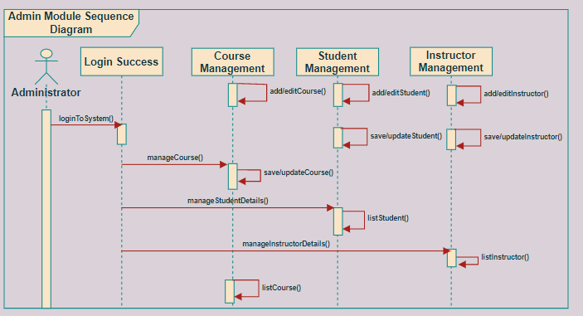

Figure 3. . Administrator Module Sequence Diagram

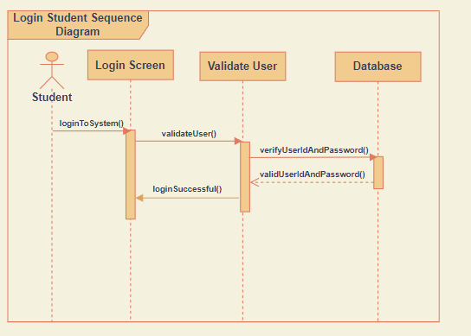

Figure 3. . Login Student Sequence Diagram

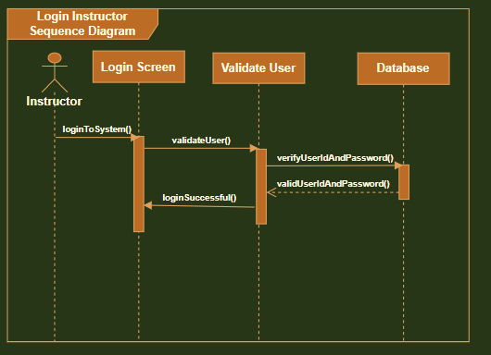

Figure 3. . Login Instructor Sequence Diagram

# CONSTRUCTING THE COURSE MANAGEMENT SYSTEM

Flowchart of proposed Course Management System by Administrator’s role

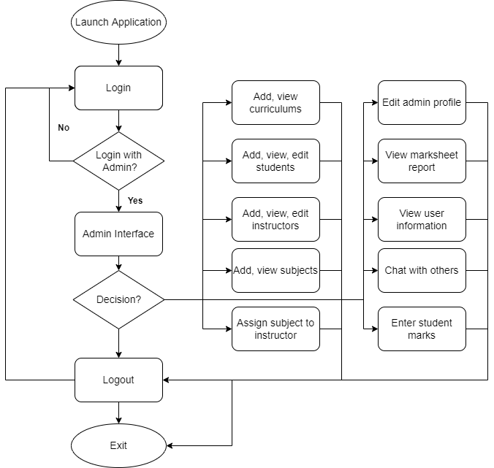

Figure 4. . Flowchart of proposed Course Management System by Administrator’s role

Administrator can do almost anything with the database. Administrators have to understand the information provided from the database to perform reasonable operations with students and instructors.

Notice: when admin create a student or an instructor, an user account will be automatically created with unchangeable username and default password.

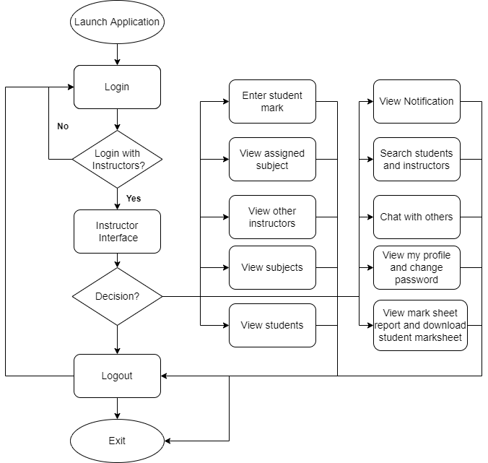

Figure 4. . Flowchart of proposed Course Management System by Instructor’s role

These are the basic features that an instructor can do, the role of the instructor will definitely be higher than that of the students, so they can do more things as well as interact with students.

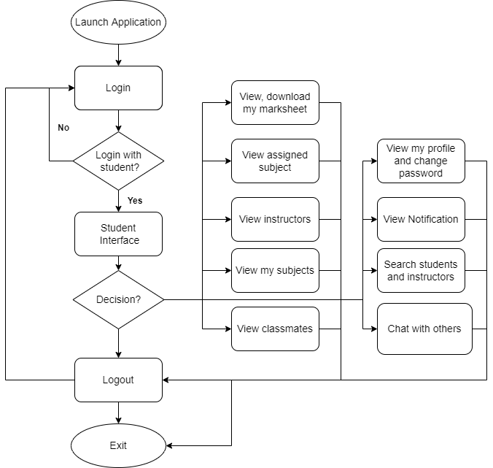

Figure 4. . Flowchart of proposed Course Management System by Student’s role

A student has basic features, they can chat in chat panel to discuss with the instructor what is needed.

# DEMO PROJECT

## Login

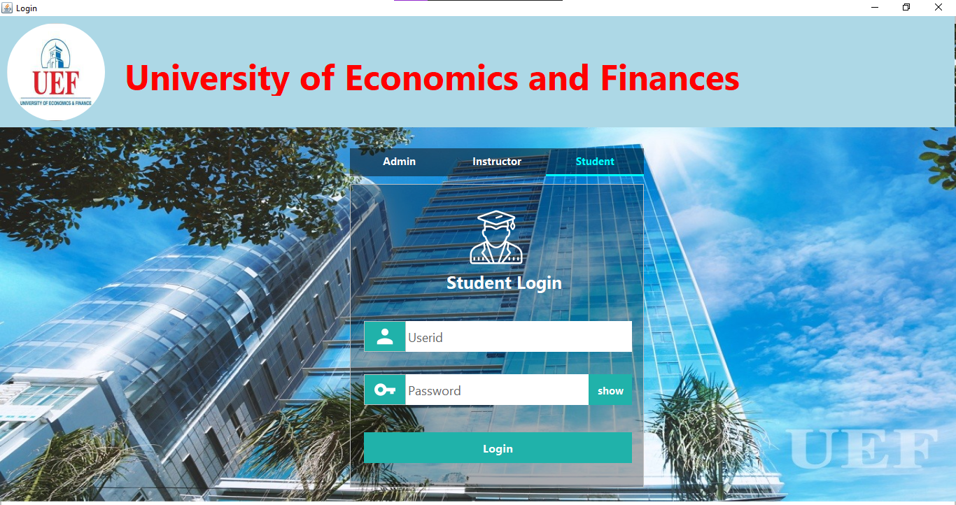

Figure 5. . Login

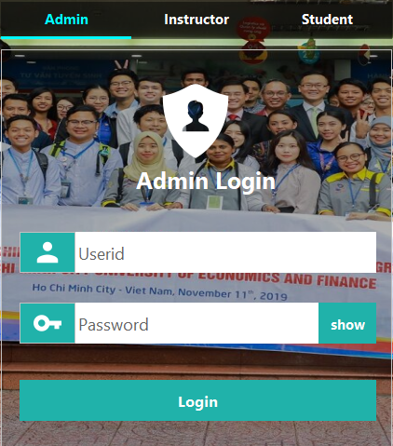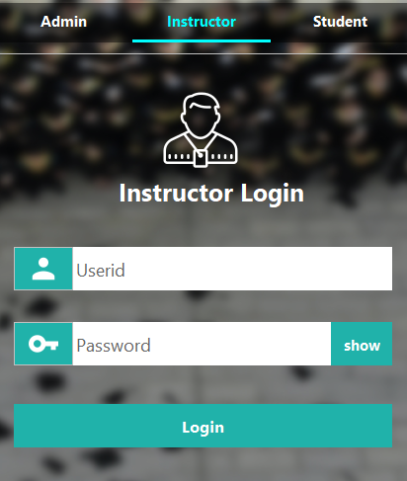

## Admin Interface

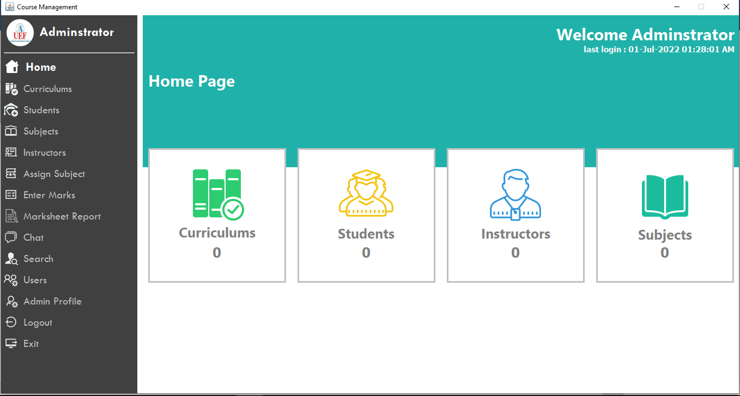

***Figure 5. 2.*** *Admin Home panel*

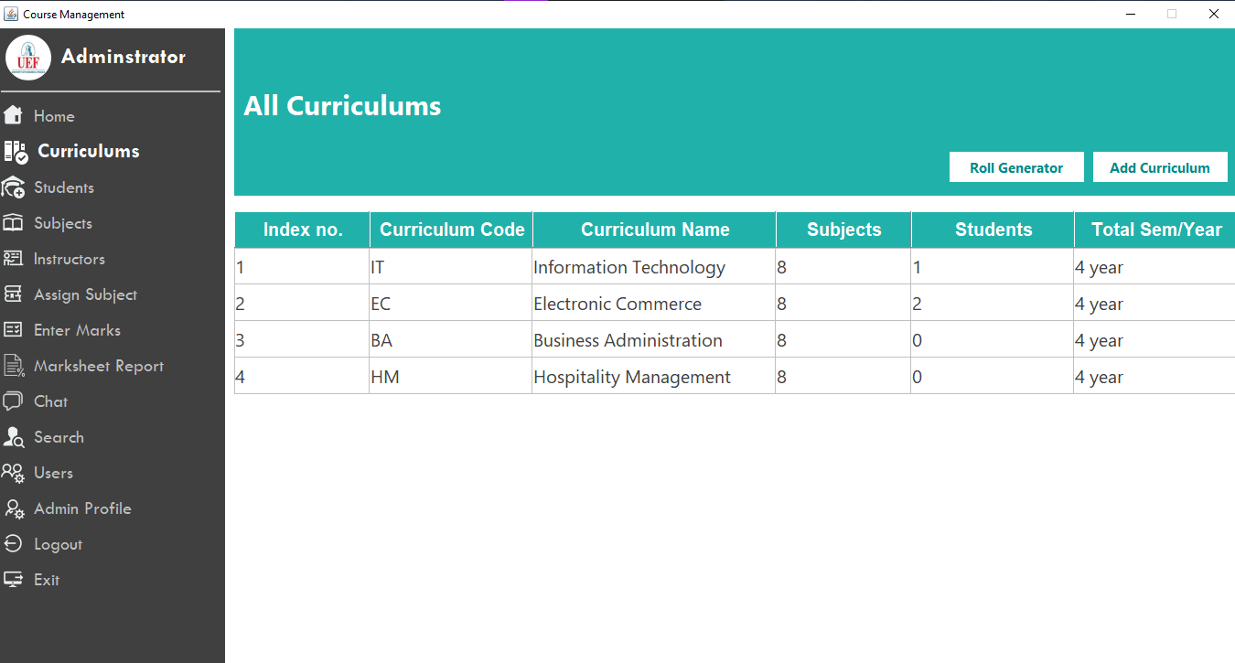

***Figure 5. 3.*** *Curriculums panel*

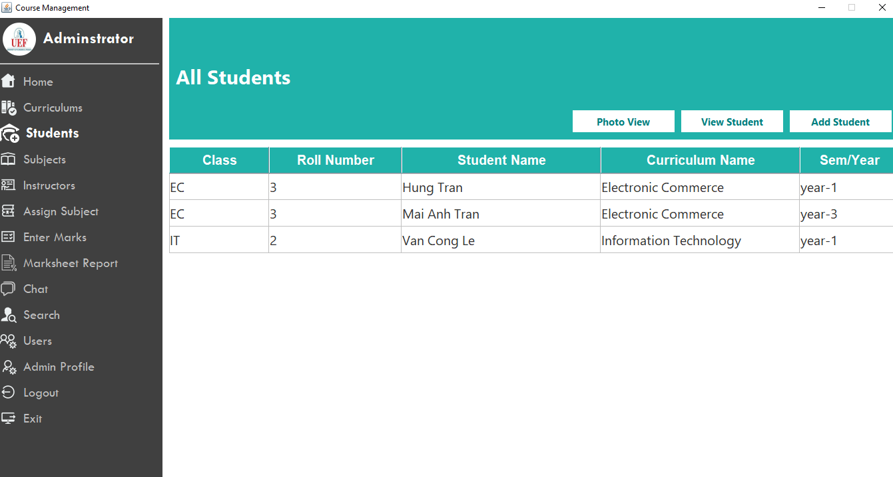

***Figure 5. 4.*** *Student panel*

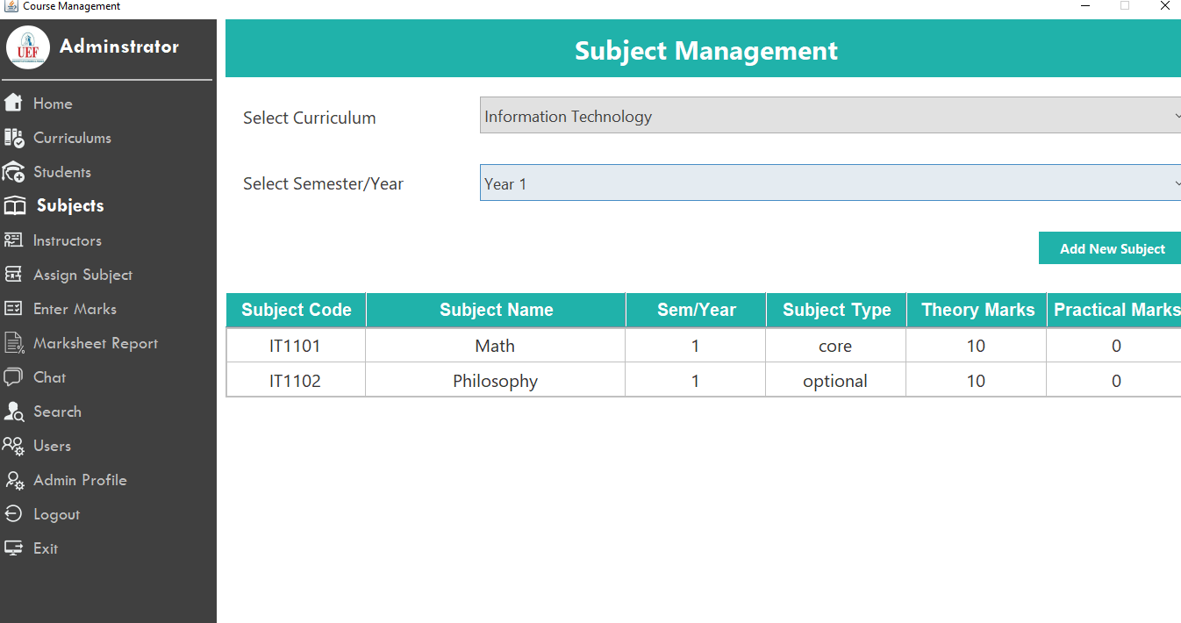

***Figure 5. 5.*** *Subjects panel*

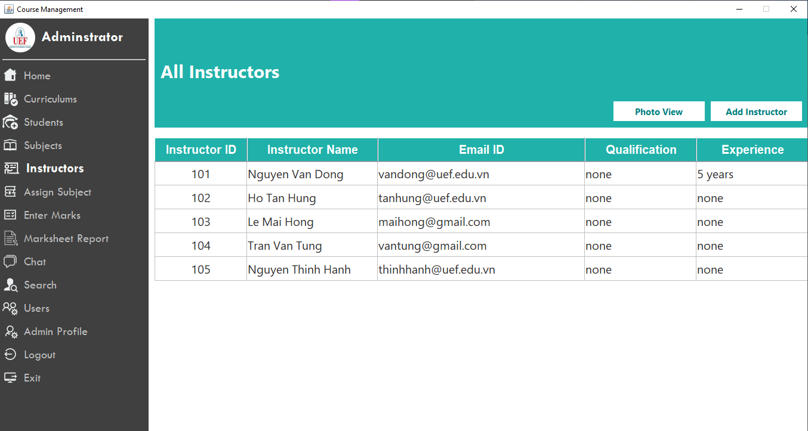

***Figure 5. 6.*** *Instructors panel*

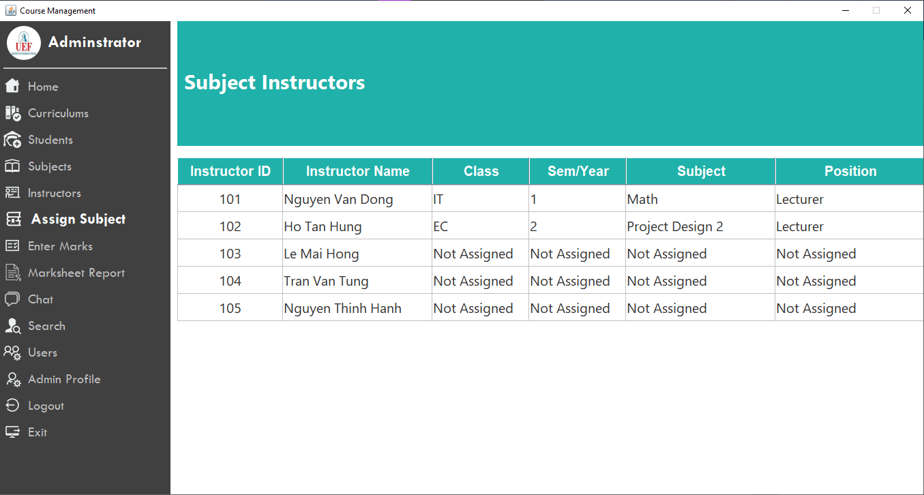

***Figure 5. 7.*** *Assign Subject panel*

**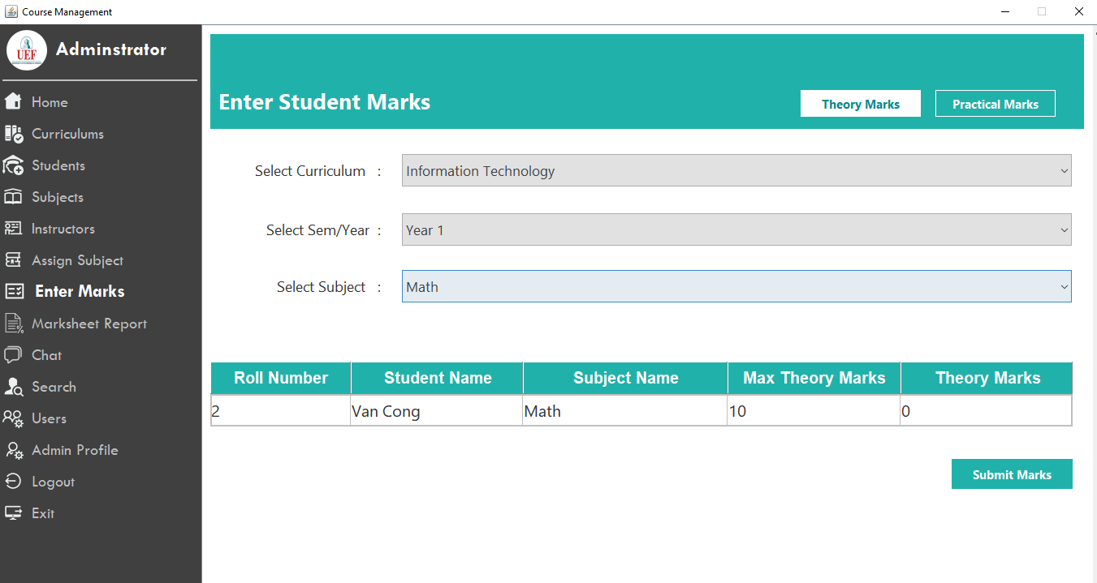*Figure 5. 8.*** *Enter Marks panel*

**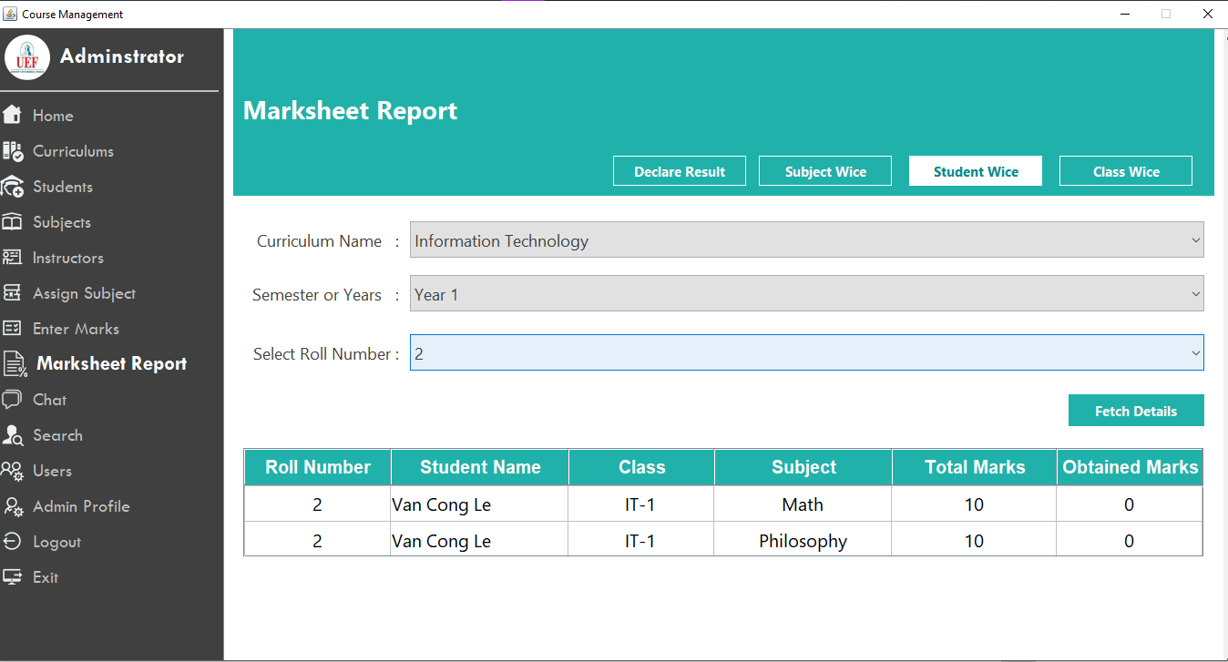*Figure 5. 9.*** *Marksheet Report panel*

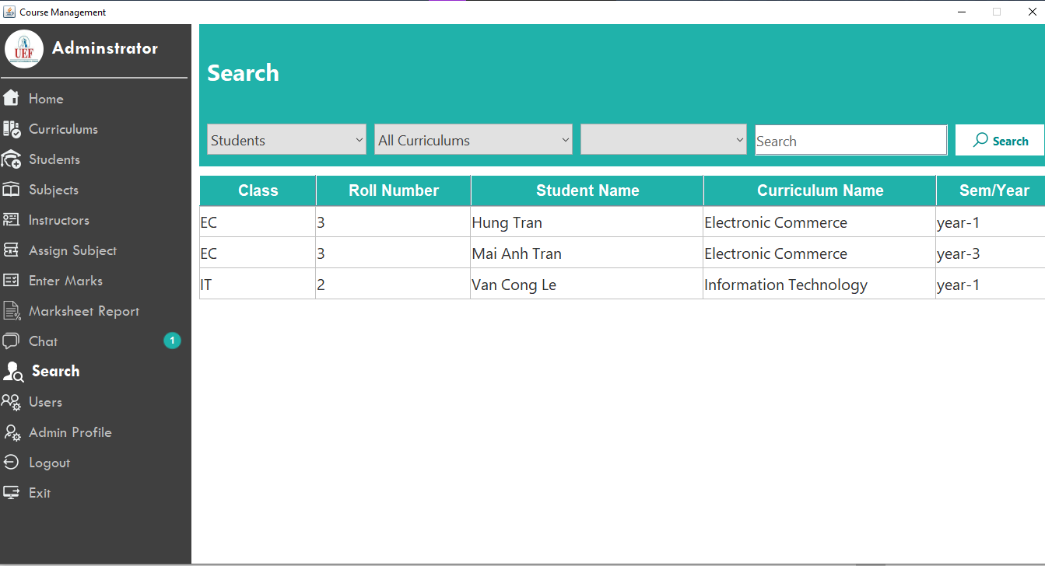

***Figure 5. 10.*** *Search panel***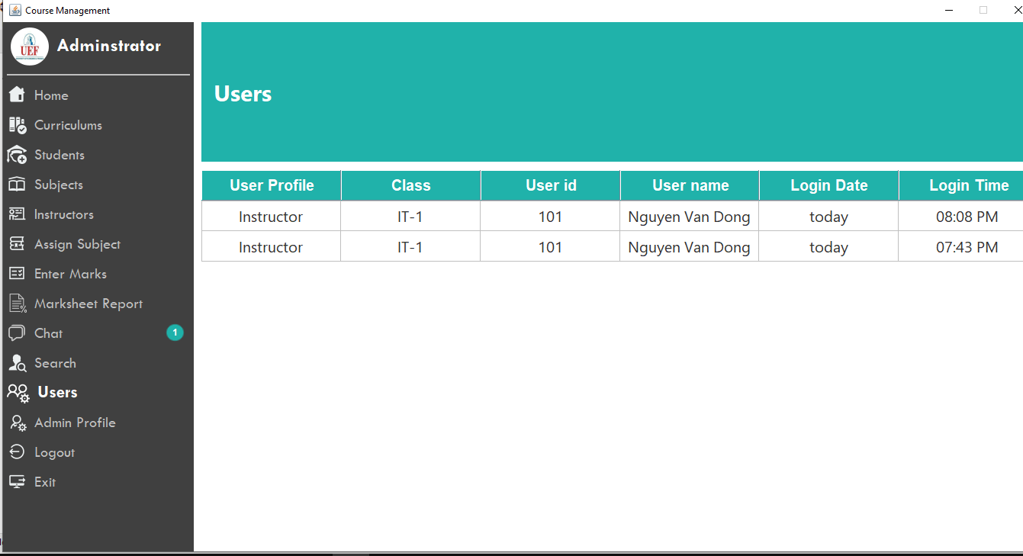**

***Figure 5. 11.*** *View user panel*

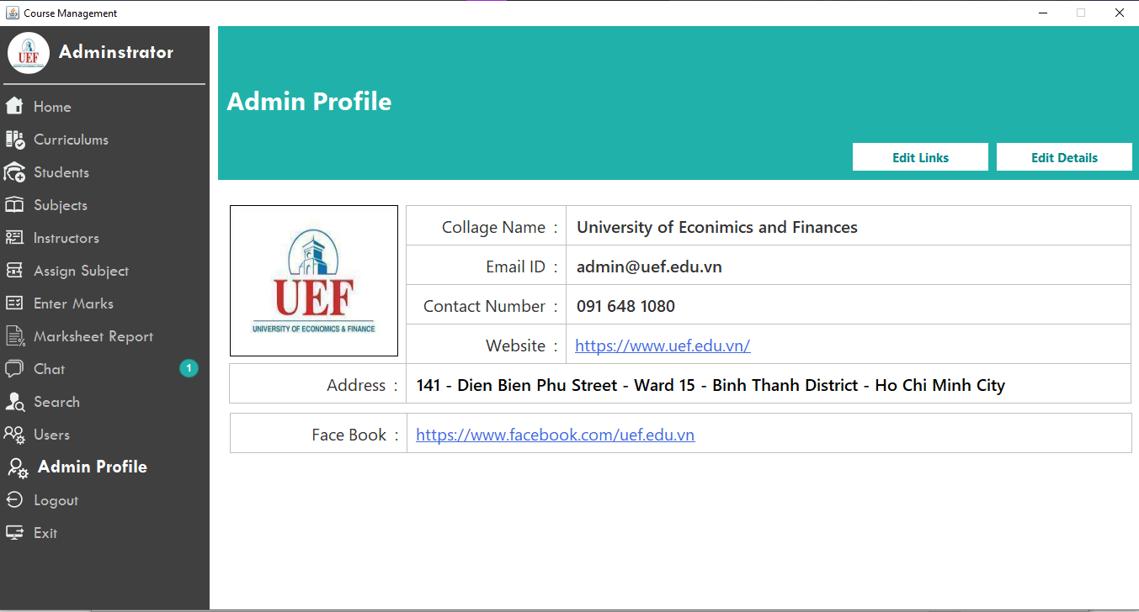

***Figure 5. 12.*** *Admin profile panel*

**5.3 Instructor interface**

Some panels are quite similar to admin, but there are some panel with special new features:

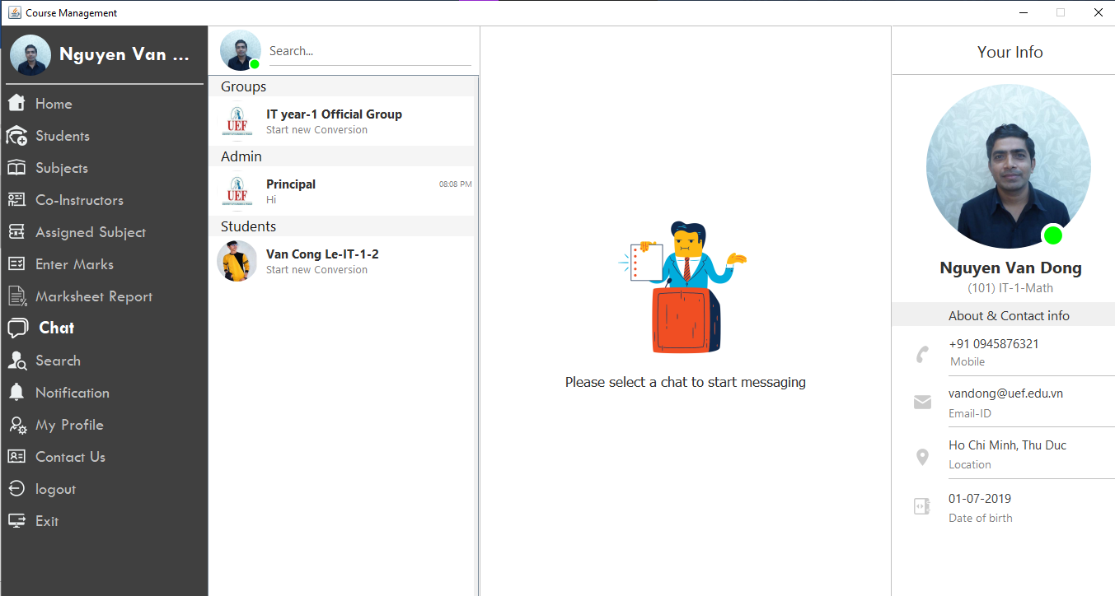

Figure 5. . Chat panel

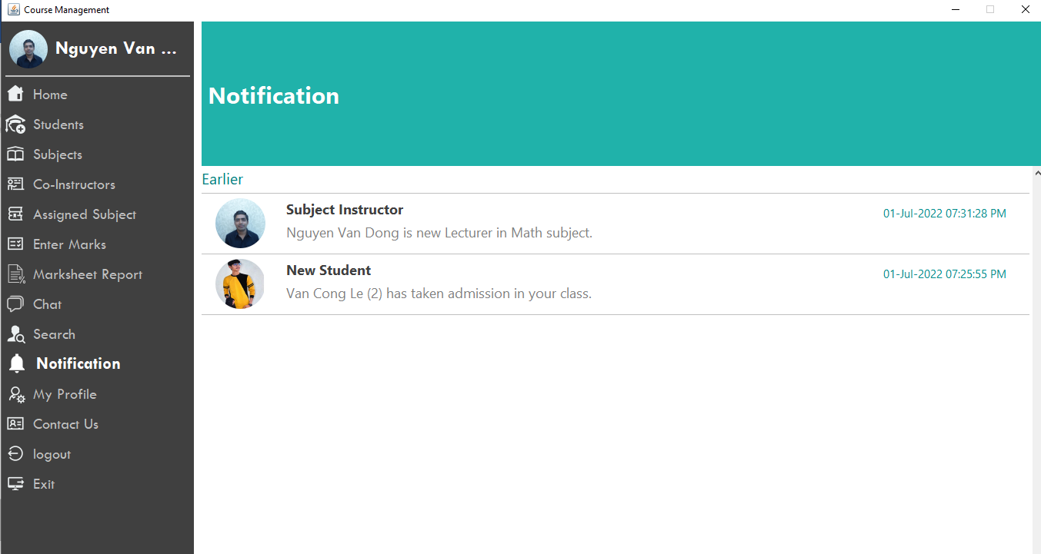

***Figure 5. 14.*** *Notification panel*

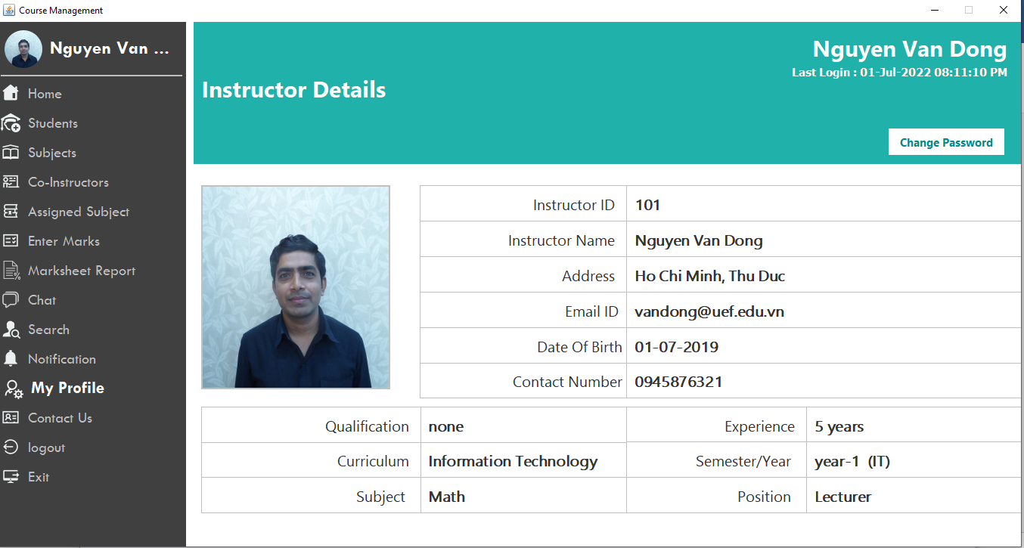

***Figure 5. 15.*** *My profile panel*

**5.4 Student Interface**

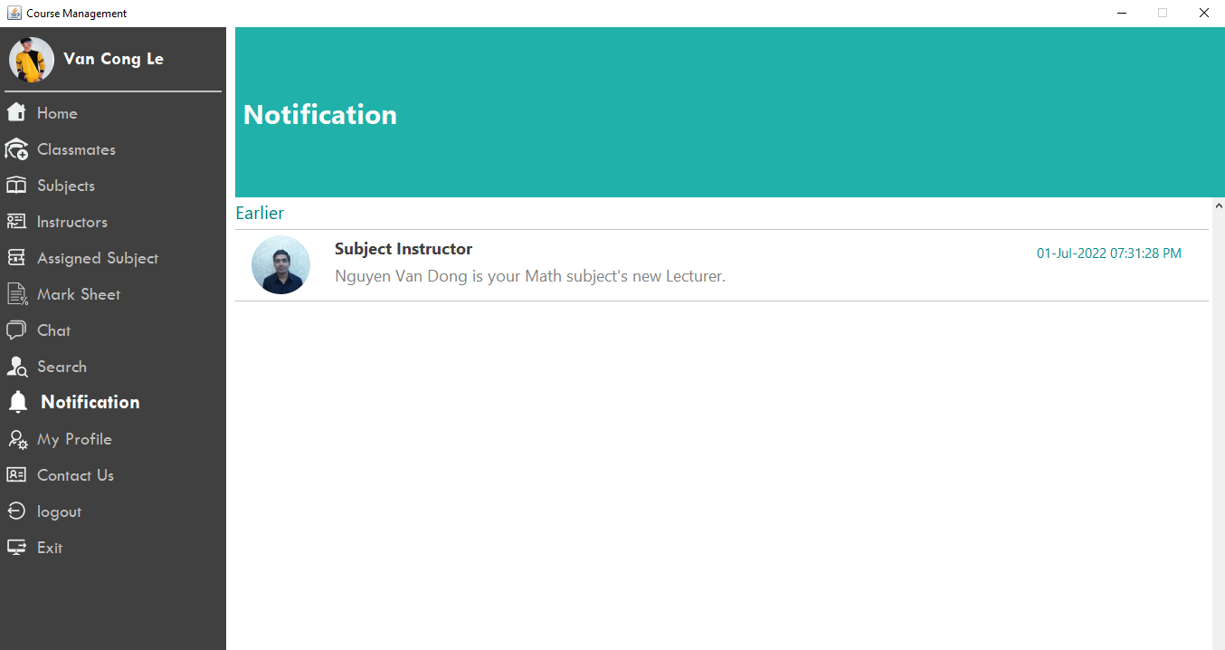

***Figure 5. 16.*** *The notification panel of student role. Students only receive the notifications in which are directly relevant to them*

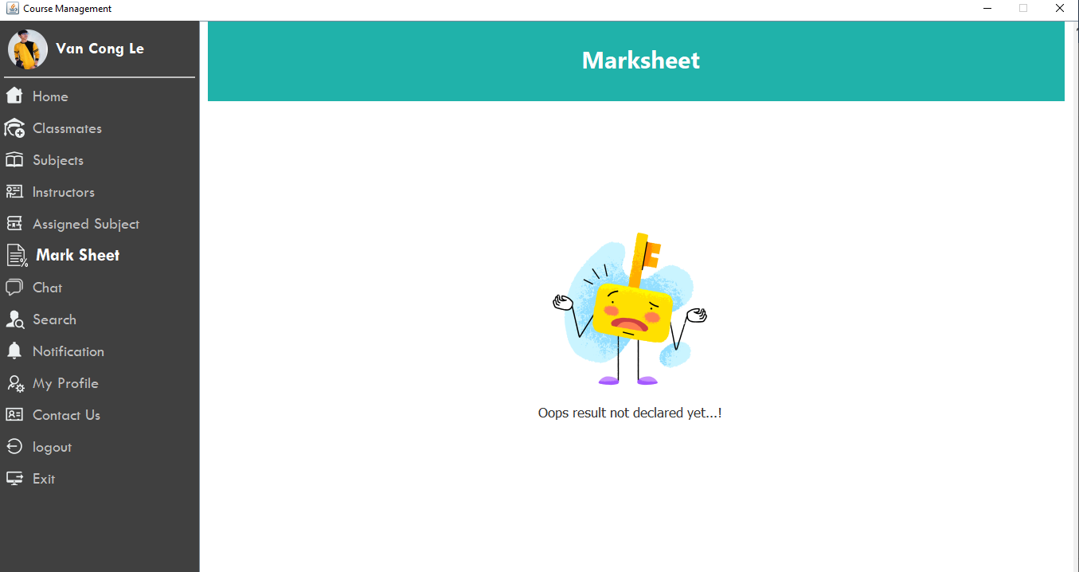

***Figure 5. 17.*** *The marksheet report of a student is only viewed after their curriculum was declared.*

# Conclusion And Future Development

## Conclusion

After going through the steps of planning and gathering requirements as well as modeling the system, our team has developed a course management system that can be said to be fully featured and suitable. with the given requirements. Although it seemed quite simple, during the build of the system we faced many errors and fixed it. To make it easy for users to use the application, we have drawn up the system functions and improved its accuracy. Hopefully this application will be suitable and meet the needs of users.

## Outcome

From building this system, it has provided us with some skills in editing and need to prepare well the design and planning steps before starting to make the application, in addition it also provide some skills such as: how to architect an application and building system in Java, teamwork and other skills.

## Limitation

This is an application that integrates 3 different modules and due to limited knowledge of both the subject and the reality of the system, it is certain that our system will encounter some limitations, notably:

* + - There is no function that allows instructor to check the projects submitted by the students.

## Future Development

My group's application development direction is to complete to check the projects submitted by the students for instructor, build payment methods on the system linked with banks to let students easily pay tuition fees and pay teachers.

**Link Source Code:**

**https://drive.google.com/drive/u/1/folders/1_34tNL07DqMSoSx27P-3EI7by8ncH0RC**